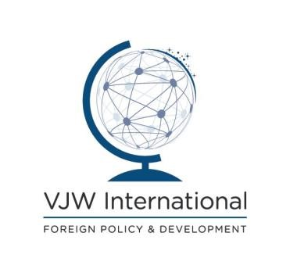

TRAINEE/INTERN VACANCY IN BUSINESS DEVELOPMENT

About us
VJW International is a specialised consultancy company in the field International
Development Cooperation and Foreign Policy. VJW provides technical expertise to public and private clients in the fields of foreign policy and development cooperation including the European Union, partner countries’ Governments, DFID, the United Nations, the World Bank etc.
We offer a thriving and challenging international environment to work in.

Profile sought
- Ideally qualified in development studies, international affairs, law or economics with a career interest in Development Cooperation.
- Strong research and drafting skills.
- Pro-active personality with strong research and organisation skills.
- Confidence to communicate with professional counterparts at all levels.
- Ability to use both Word and Excel.
- Meticulous with attention to details.
- Mother tongue English – ability to write to a high standard.
- French and other languages considered an asset.
This internship provides the intern with the opportunity to:

- Gain experience in the field of international development and foreign policy
- Gain practical experience in the intern’s field of academic study, thus facilitating the transition between academic study and chosen career;
- Develop employability skills in general.
- Gain confidence and develop a stronger set of personal and professional skills.
- Develop more effective written and communication skills.

a) The intern will handle the following assignment/tasks:

- Support to the identification of new business development opportunities for international Development Cooperation projects including the identifying of potential consortium partners,
- Support the preparation of bids including the drafting of project proposals, the compilation of administrative tender dossiers;
- Support the identification of suitable experts and keep the experts’ database up to date; Keeping abreast of developments, events and news in the field of Development Cooperation.

Conditions, duration and location
- The internship is unpaid. The intern will have his travel paid and receive a daily food allowance.
- Location: London/Brussels
- Duration: 4 weeks to 8 weeks maximum

If interested, please send your CV and a motivation letter to VJWteam@vjwinternational.com with the job title/your name in reference.

Deadline: 30/05/2020. Kindly note that only applicants meeting the essential requirements will receive a reply.

Thank you for your interest and good luck with your application!

